LAPORAN RESMI

PRAKTIKUM PEMROGRAMAN BERORIENTASI OBJEK

STUDI KASUS 23



Fadilah Fahrul Hardiansyah S.ST., M. Kom

Ratri Maria Manik

3121600039

D4 TEKNIK INFORMATIKA – B

PROGRAM STUDI TEKNIK INFORMATIKA

POLITEKNIK ELEKTRONIKA NEGERI SURABAYA

TA 2022/2023

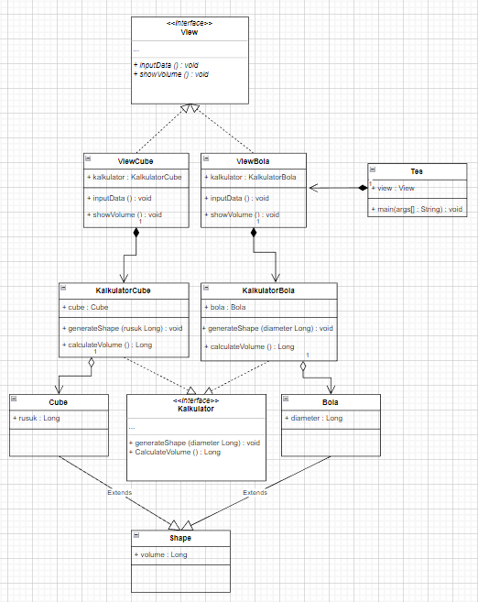

**Source Code :**

1. **Bola.java**

1. **Cube.java**

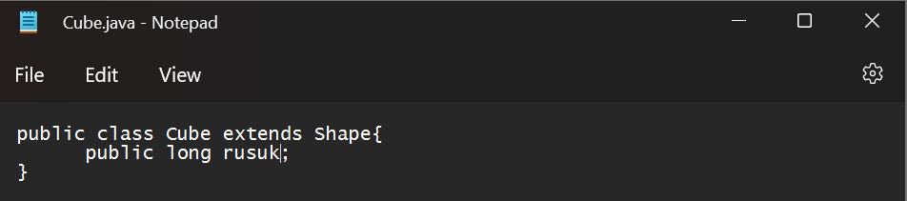

1. **Shape.java**

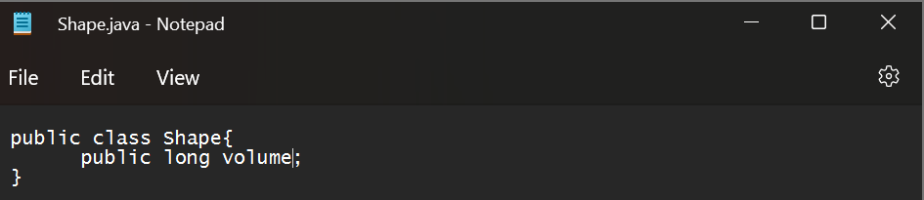

1. **Kalkulator.java**

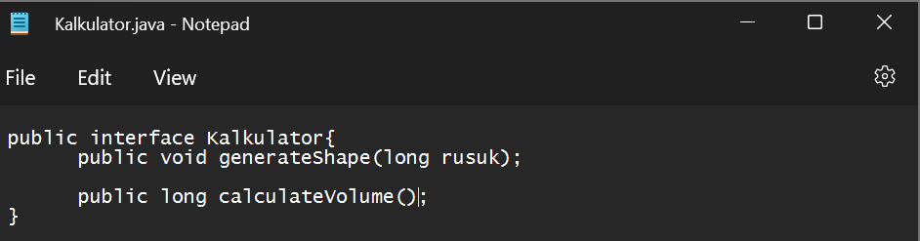

1. **KalkulatorBola.java**

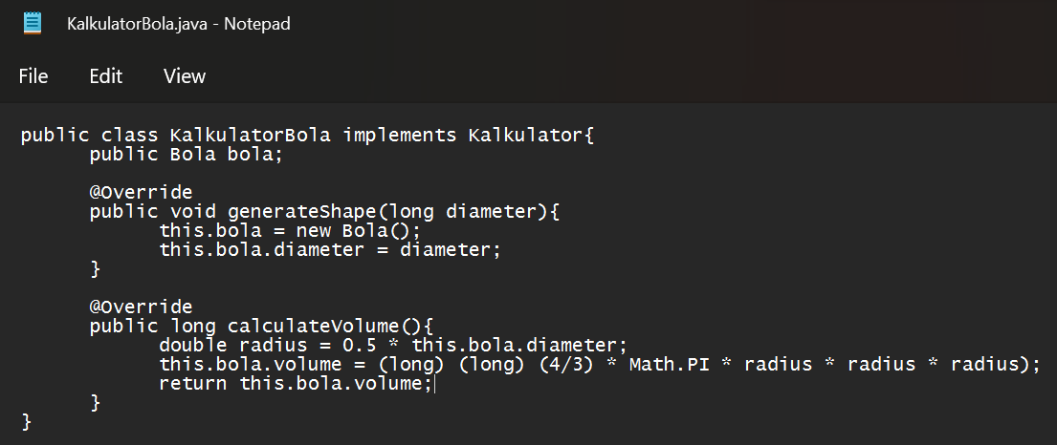

1. **KalkulatorCube.java**

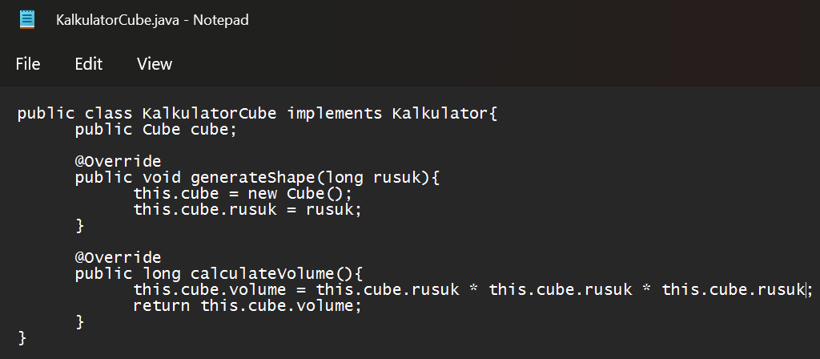

1. **View.java**

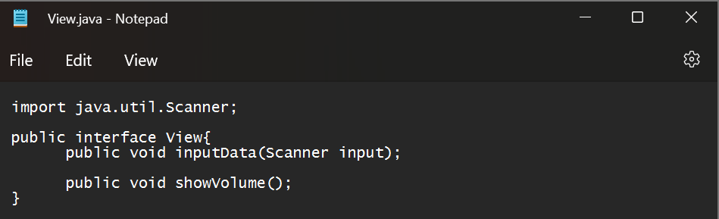

1. **ViewBola.java**

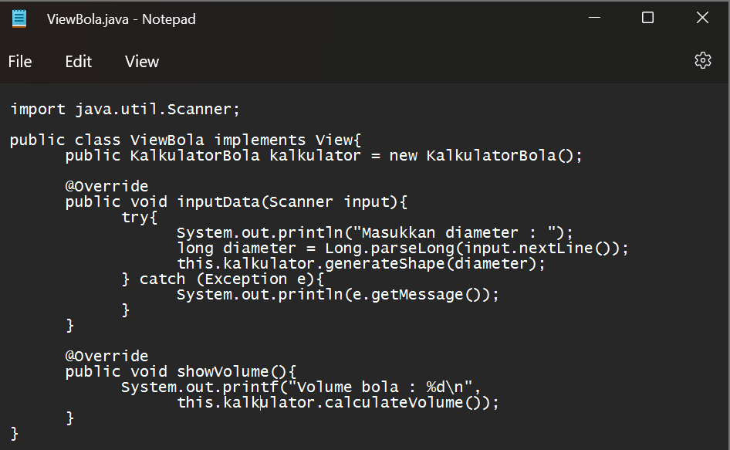

1. **ViewCube.java**

